List of Artisans
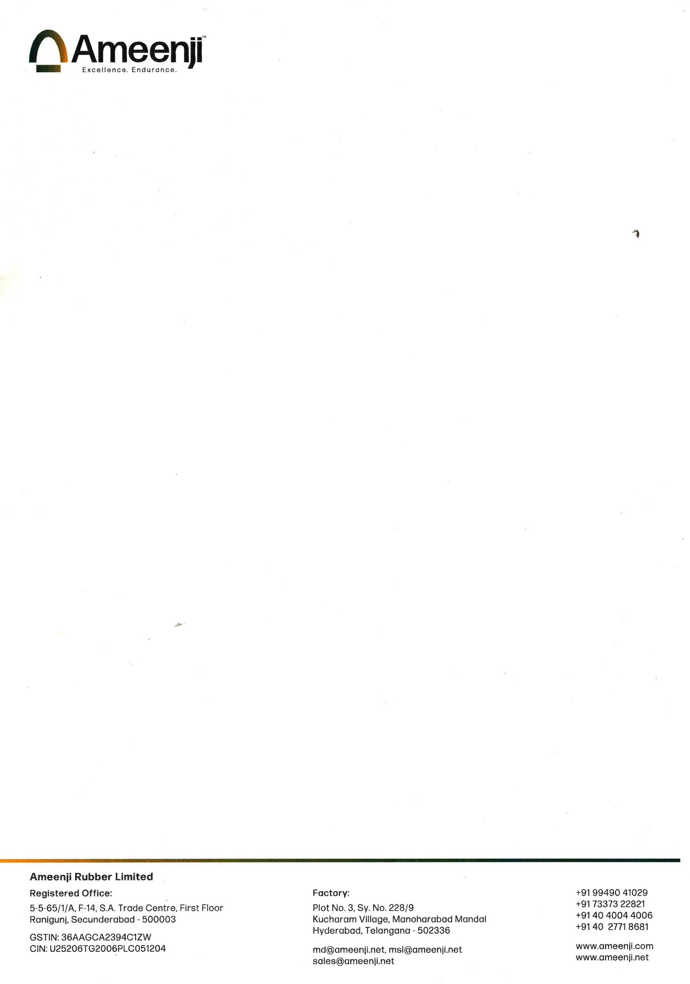
SN | Name | Designation | Technical Qualification | Experience | Brief Scope of Responsibilities
1 | Mr.Dharmendra Kumar | Manager Production | B.Tech | 8 Years | Production Engineer
2 | Mr.Sukjender Singh | Manager Maintenance | B.Tech | 8 Years | Electrical Engineer
3 | Mr. Sri Hari Reddy | Asst. Manager Maintenance | B.Tech | 10 Years in Rubber | Mechanical Engineer
4 | Mr.Veera Gopi | Asst. Manager Maintenance | B.Tech | 10 Years | Engineer-Fabrication
5 | Mr.Sheshu Babu | Asst. Manager Maintenance | B.Tech | 10 Years | Engineer-Fabrication
6 | Mr. Naveen | Engineer - NDT | B.Tech | 4 Years | NDT Lab & Finished Product Inspection
7 | Mr. Lal Saheb | Superviser | SSC | 20 Years | Fabrication Stores Incharge
8 | Mr. Guddu Kumar | Welder | SSC | 10 Years | Certified welder
9 | Mr.Shiv Kumar | Welder | SSC | 8 Years | Certified welder
10 | Other technicians & Articians | Operators & Helpers | ITI/SSC | 2 Years | Cutting/ Bending/ Milling etc.

